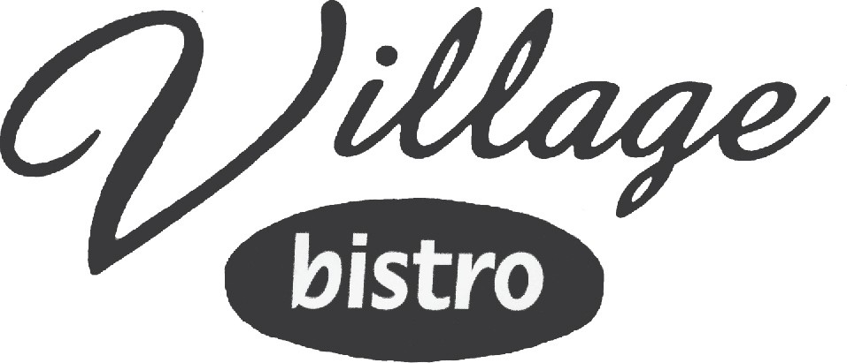

**$11.89**

**$10.49**

**Footlong**

**$10.79**

**$11.58**

**$12.23**

**$12.90**

**6”**

**$7.79**

**$8.34**

**$8.87**

**$9.42**

**$5.29 .99**

**Sml$2.09 Lrg.2.29**

**$2.29**

**HOT/COLD SUBS & SANDWICHES**

**Subs served with Lettuce, Tomato, Red Onion, Cheese, Mayo & Golden Italian**

**STEP 1: Choose Your Meats - (up to 4)**

Choose from Pit Ham, Oven-Roasted Turkey, Salami or Roast Beef

**STEP 2: Choose Your Hoagie**

Choose from White, Italian White, Wheat or Rosemary Wheat

**STEP 3: Choose Your Cheese**

Our cheese include Cheddar, Mozzarella, American, Provolone, Swiss or Pepper Jack

**STEP 4: Choose Your Chips:All Subs come with chips**

1. **MEAT**
2. **MEATS**
3. **MEATS**
4. **MEATS**

**817.579.9100**

***We Deliver to All of Pecan Plantation***

**PIZZA SANDWICHES SALADS & SOUPS PASTA**

**GOURMET SWEETS**

**2800 Village Rd, Suite 100**

***Granbury, TX 76049***

[**www.pecanvillagebistro.com**](http://www.pecanvillagebistro.com/)

**PIZZA SUB**

**Homemade marinara sauce, pepperoni & mozzarella cheese.**

**SPICY RANCH BUFFALO**

**Breaded chicken tenders, ranch dressing, Frank’s Wing Sauce and provolone cheese, Topped with lettuce and tomato.**

**$7.29**

**$7.79**

**$12.29**

**CHICKEN PARMESAN**

**Breaded chicken tenders, homemade marinara sauce and mozzarella.**

**MEATBALL SUB**

Homemade marinara and meatballs topped with mozzarella cheese and toasted to perfection.

**CHEESESTEAK SUB*(ONLY Mondays & Fridays)***

Thin sliced beef served with onions and bell peppers then topped with provolone cheese.

**CROISSANT CHICKEN SALAD SANDWICH**

Topped with lettuce and tomatoes, served with fresh fruit.

**TOASTED BLT**

Served on white, wheat or sourdough toast, no substitutions.

**TOASTED TUNA SANDWICH**

Served on white, wheat or sourdough toast no substitutions.

**GOURMET SWEETS**

**CINNAMON PULLS**

Delightful cinnamon wonders! A sprinkling of cinnamon and sugar cover our buttery loaf of bread. Served with icing.

**VARIETY OF CAKES, PIES COOKIES(INDV)**

**$7.79**

**$12.29**

**$7.799**

**$7.79**

**$12.29**

**$11.79**

**$8.15**

**$8.15**

**$3.89 0.75**

**Monday - Saturday**

**11:00 am - 8:00 pm**

**Closed Sundays**

**BEVERAGES**

**Fountain Drinks Or Iced Tea**

**Fresh K-Cup Coffee**



**CALZONE**

**Pizza pocket with up to 3 ingredients topped with garlic butter and parmesan.$9.99**

**SOUPS & SALADS**

**All salads served with a mixture of fresh leafy greens.**

**Dressings: Ranch, Italian, Creamy Italian, Honey Mustard, Bleu Cheese, Fat Free Raspberry Vinaigrette &Garlic Balsmic.**

**Side Salad**

Fresh greens, mozzarella cheese and cherry tomatoes.

**Half $4.99 - Full $7.29**

**ULTIMATE PIZZAS**

**Small $13.99 - Medium $16.99 - Large $20.99 - XL $23.99**

**Alfredo Chicken Pizza**

Mozzarella, Alfredo sauce, extra chicken, green pepper, onion & cheddar cheese.

**Popeye Spinach Alfredo**

Baby spinach, mushrooms, Alfredo Sauce, mozzarella cheese, crushed red pepper & tomato.

**Nacho Pizza**

Thin Crust smothered with refried beans, mozzarella and cheddar cheese, fajita chicken, onions, jalapenos and black olives.

**Village Idiot Pizza**

**BBQ Chicken Pizza**

Mozzarella, cheddar cheese, chicken, onion & green pepper. Served on a tangy bed of

BBQ sauce.

**Lite Village Idiot Pizza**

Pepperoni, canadian bacon, mozzarella, mushrooms, green peppers and onions.

**Garden Salad**

Fresh greens, cherry tomatoes, red onion, green pepper, black olives and mushrooms Half $6.69 - Full $8.79

**Grilled Chicken Salad**

Fresh greens, fajita chicken, cheddar cheese, green pepper, red onion, black olives and cherry tomatoes.

**Half $8.99 - Full $11.89**

**Quesadilla Chicken**

**Pizza**

Sandwiched thin crust topped with chicken, onion, jalapeno, mozzarella & cheddar cheese. Served with savory salsa.

**Crispy Chicken Salad**

**Mozzarella, pepperoni, beef, canadian Village Veggie Pizza**

bacon, sausage, mushroom, green pepper, onion and black olives.

**Monster Meat Pizza**

Fresh greens, crispy chicken, cheddar cheese, green pepper,red onions,

black olives and cherry tomatoes.

**Half $8.99 - Full $11.89**

**Plantation Trio Salad**

Fresh greens, thin sliced canadian bacon, red onions, mushrooms, bacon, green peppers, mozzarella and cherry tomatoes.

Half $9.29 - Full $11.89

Mozzarella, mushroom, onion, tomato, black olives and green peppers.

**Bacon Cheddar Burger**

Mozzarella, pepperoni, beef, bacon, Canadian bacon and sausage.

**Pepperoni Xtreme Pizza**

Double pepperoni and extra mozzarella.

**Pizza**

Cheddar cheese, mozzarella, extra beef, bacon, green pepper and onion.

**Fruit Cup**

**SOUP**

Variety of seasonal fruits. - $3.99

Cup $3.99 - Bowl $5.49

**CUSTOM CREATED PIZZAS**

**Small $9.99 - Medium $11.99 - Large $14.99 - XL $16.99**

**Choose From These Fresh Toppings:**

**Bacon, Beef, Black Olives, Green Olives, Green Peppers, Canadian Bacon, Cheddar Cheese, Fajita Chicken, Italian Sausage, Jalapeno, Mushrooms, Onions, Pepperoni, Pineapple, Tomato, Anchovy, Spinach**

**CHICKEN WINGS & TENDERS**

**Yard Bird Filets**

Half dozen breaded 100% chicken breast filets. Served with your choice of honey mustard, bbq or ranch dressing. - $8.49

**Yard Bird Wings**

(10) or (20) Piece wings cooked and tossed in-house with flavors of HOT,BBQ,GARLIC PARMESAN OR PLAIN(10 pc.) $9.49 - (20 pc.) $18.49

**Chicken Bites 100% All white meat breaded chicken chunks.**

Served with your choice of honey mustard,ranch,or bbq sauce- (7 pc.) $5.59 - (12 pc.) $7.99

**Additional Toppings $1.50 ea. ($2.00 on the XL) Alfredo or BBQ Sauces Additional $3.00**

**Crust Selection:**

**Hand-Tossed, Thin Crust, Garlic Butter, or Garlic Parmesan Cheese,**

**\*Gluten free pizza crust - 1 size - 10.5” for an additional $5.29**

**Cheese Ravioli or Stuffed Cheese Manicotti**

**Served with (2)garlic breadsticks $7.29**

**BREAD & CHEESE STICKS**

**Garlic Cheese Sticks**

Perfectly baked bread sticks with melted mozzarella cheese and

garlic butter, Served with marinara sauce. Sm. $7.99 - Med. $9.99 - Lg. $11.99 - XL

$14.99

**Bread Bites**

Baked small sticks of our wonderful pizza dough, covered with

garlic butter and sprinkled with parmesan cheese. Served with garlic butter. - $6.99

***Prices subject to change.***

**Thank You for Your Support!**

***Prices subject to change.***